Changes for Migrate 2 west website


Change the colour of suitcase from blue to the same orange in 2 and then also update that logo in everyplace where required
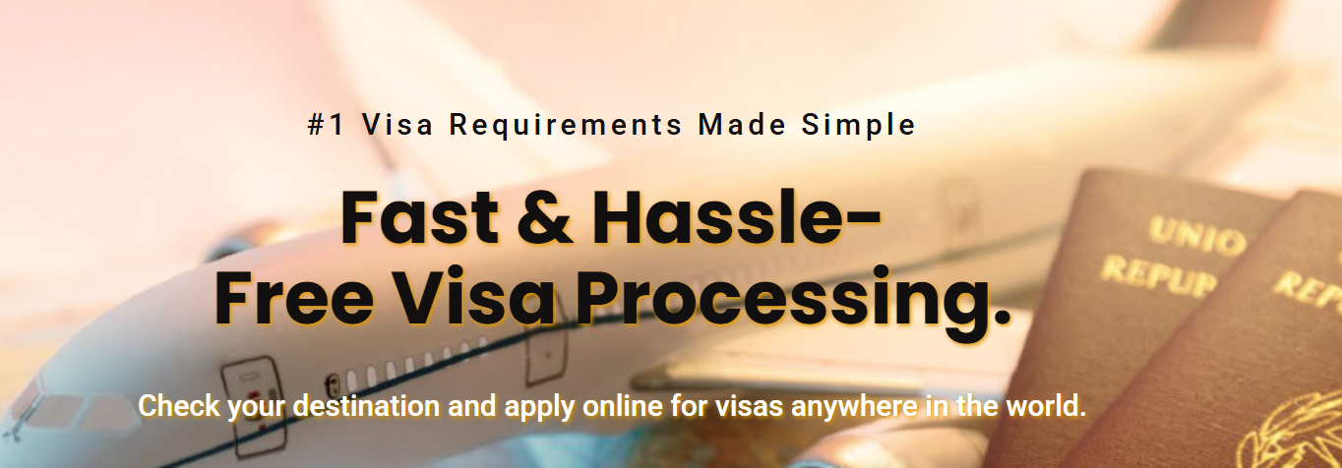
The text background stroke effect is not looking good, change it asap and make it decent and simple.
and the most importantly the CONTACT FORM
contact form should be include these details

- Nationality
- What type of service required
(10 services include in the dropdown option)
- Passport assistance
- Visa
- Air ticket
- Hotel confirmation
- Travel insurance
- Permanent residence
- Job seeker visa
- FRRO
- OCI
- Tour packages

After this is customer select passport assistance then the actual form should begin
- Name
- no. (also get verified with mobile OTP)
- Email ID
SUBMIT BUTTON
- Then it should redirect to second page where the customer can see the pricings of the service they selected in form from the dropdown above
- Then payment options
- Then make the payment
- & Then also get an invoice
[ also there should be an option for a paid consultation with scheduling calendar and payment option in every form]

2. VISA
Now if someone select VISA from the dropdown then these below options must be visible to them.
- Type of visa
- Business visa
- Tourist visa
- Work visa
- Study visa
- Dependent visa
- Family/friend visa

- Name
- Contact no (verified by mobile OTP)
- Email ID
- Date of travel
SUBMIT OPTION
- Pricing
- Payment
- Invoice

And like this I will share every option further details to add in form.
for other UI related changes I will let you know once you have complete it from your end.

